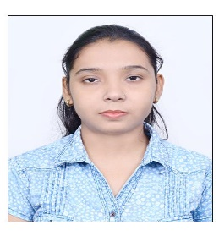**Name:** Anjali Kumari

**Email:**anjalikumari0121@gmail.com

**Phno**: 8210126280.

**CURRICULUM VITAE:**

**Objective:** Intend to build a career with an organization, where in, I can implement my Theoretical, Logical, Technical skills in the practical real-life environment with committed & dedicated people, which will help me to explore myself fully and realize my potential, Willing to work as a key player in challenging & creative environment.

**SKILL SET**

**SQL:**

* Good knowledge in writing **SQL queries**
* Good knowledge in **DDL, DML, TCL.**
* Good knowledge in **Functions.**
* Good knowledge on **Joins** and **Normalization.**
* Having very good knowledge in **Sub-queries and Co-related Sub-queries.**
* Practiced extensively on Oracle 10g database.

**ACADEMY DETAILS:**

|  |  |  |  |  |
| --- | --- | --- | --- | --- |
| Course | College/School | University | Year of Pass out | AGGREGATE |
| **B Tech** | R.V.S COLLEGE OF ENGINEERING& TECH, JAMSHEDPUR | KOLHAN | **2020** | **65.18%** |
| **DIPLOMA** | NTTF, JAMSHEDPUR | NTTF | **2016** | **71%** |
| **SSC** | KASIDIH HIGH SCHOOL, JAMSHEDPUR. | CBSE BOARD | **2011** | **72%** |

**PROJECT:**

**Title :**Smart Gardening System Using IoT

**Description :**The Smart gardening system is an IoT based device which is capable of automating the gardening process by analyzing the moisture of soil and the climate condition.

**STRENGTHS:**

* Hardworking nature
* Time management skills
* Self-motivating

Father’s Name : Swadesh Kumar Singh

**PERSONAL DETAILS:**

Mother’s Name : Sarika

Date of Birth : 29 April1995

Gender : Female

Languages Known : English, Hindi

Nationality : Indian

Marital status : Single

Hobbies :Painting, Animal Care, Travelling

Address : Q. No. 19, Roro road, Old Baridih, Jamshedpur-831017

**DECLARATION:**

I here by declare that the information furnished above is true to the best of my Knowledge.

**PLACE:** Bangalore (Anjali kumari**)**